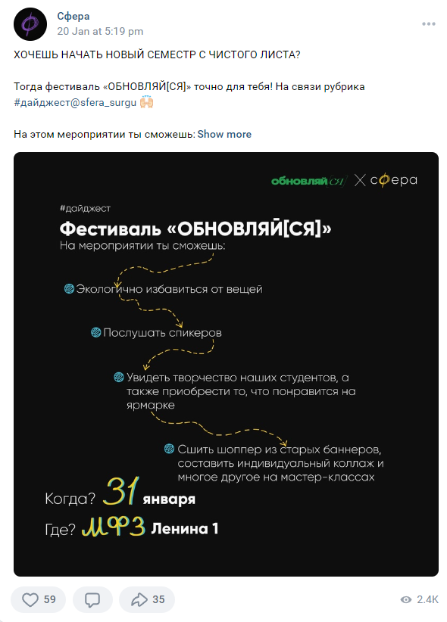

https://vk.com/sfera_surgu?w=wall-211828865_3456
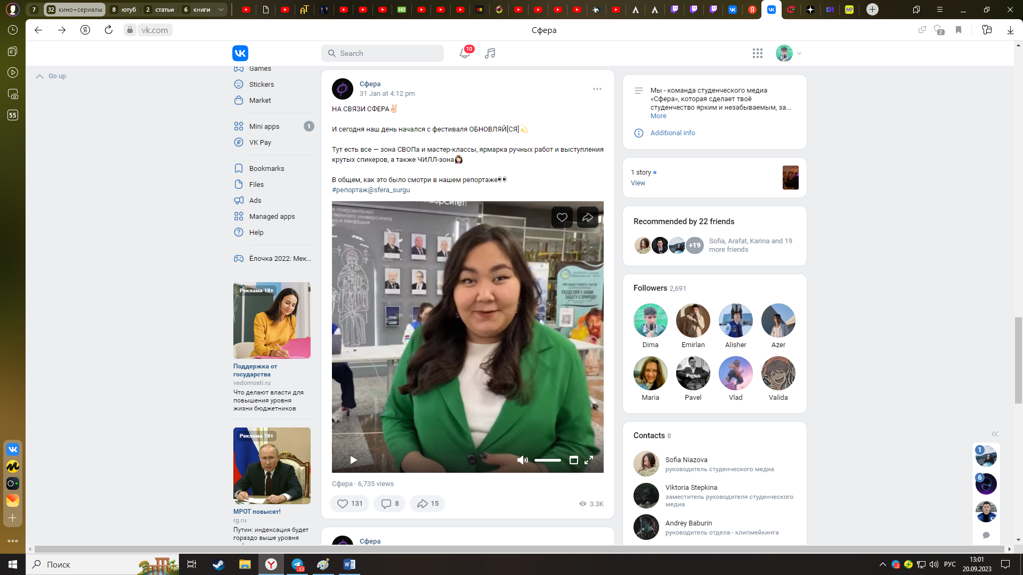

https://vk.com/sfera_surgu?w=wall-211828865_3543

