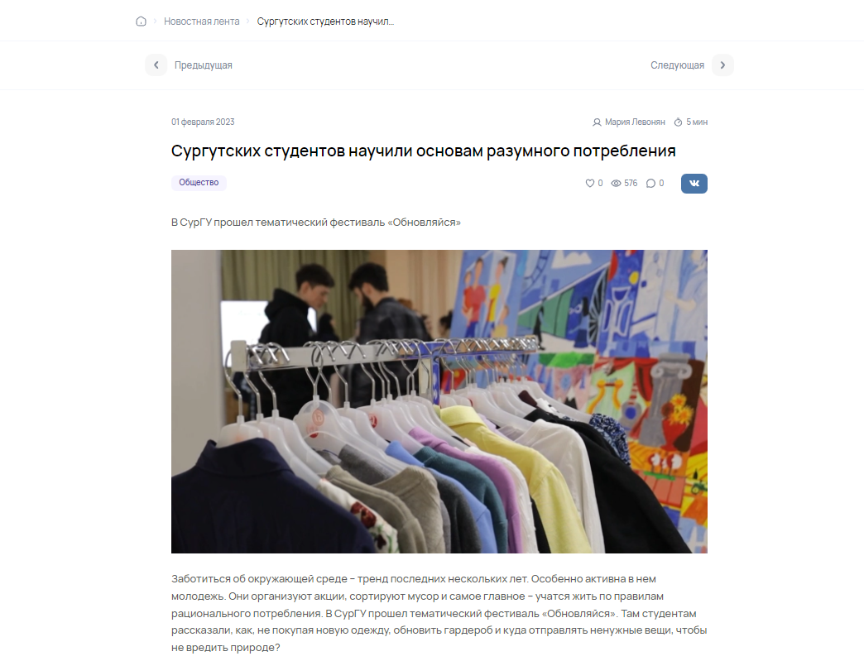
https://in-news.ru/surgut/news/surgutskix-studentov-naucili-osnovam-razumnogo-potrebleniya

