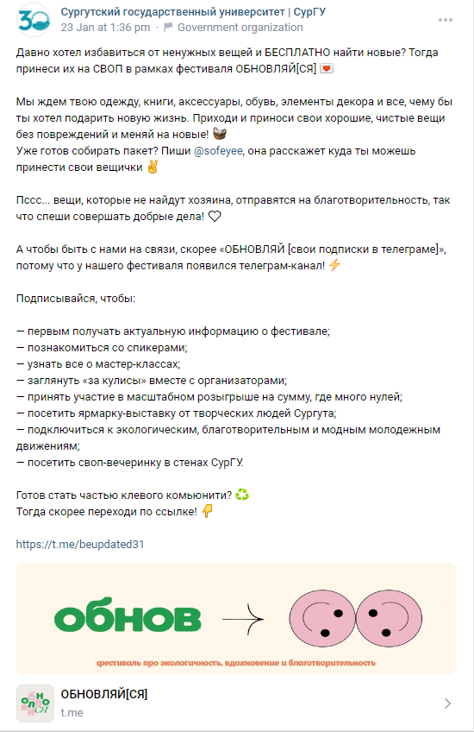

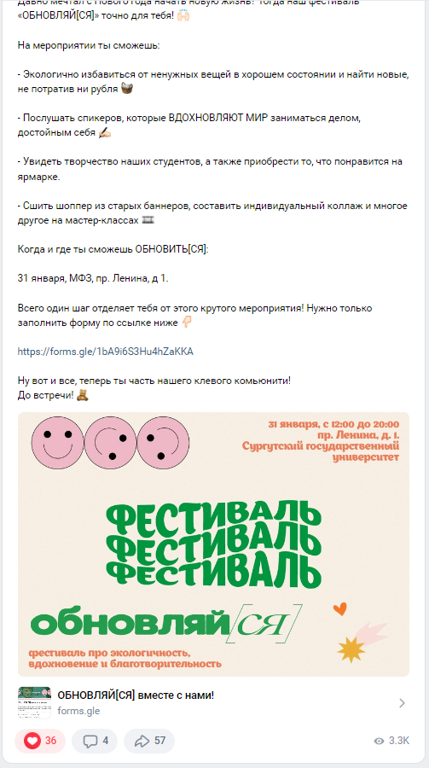
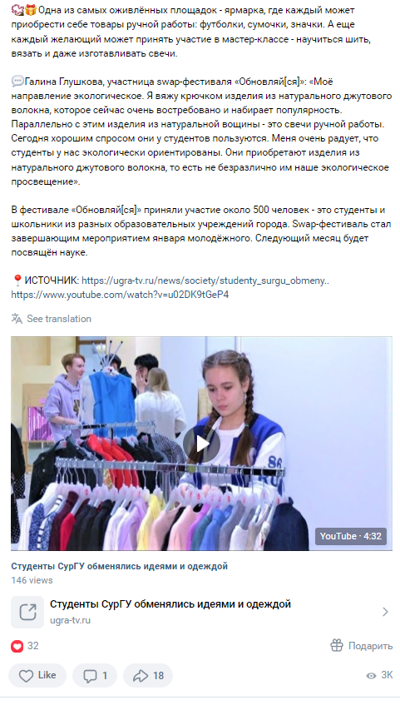
https://vk.com/wall-18121309_19430
https://vk.com/surgu?w=wall-18121309_19384
https://vk.com/surgu?w=wall-18121309_19379

